Red Hat JBoss BRMS
&
Red Hat JBoss Fuse
Fuse Integration Demo
(Use case: rules integration with ESB)

Kenny Peeples
JBoss Technology Evangelist (Integration & BPM)

Eric D. Schabell
JBoss Technology Evangelist (Integration & BPM)
Table of Contents
Introduction 2
Setup and Configuration 2
Installation 2
JBoss Developer Studio Configuration 3
Running the Demo 3
JBoss BPM Suite mortgage demo 3
Web Designer 3
Rule asset viewing 4
Build package for deployment 4
Business Central 4

Introduction
This project was setup to demonstrate an actual integration between Red Hat JBoss BPM Suite and Red Hat JBoss Fuse products. It will provide you with an architectural blueprint for calling out to a JBoss BRMS engine from within your JBoss Fuse service bus messaging (Camel) routes. The project provided here will get you started quickly on the road to integration in practice.

Setup and Configuration

Installation
You first need to get the project by downloading or cloning it from the central location:

- download and unzip:
  - https://github.com/eschabell/brms-fuse-integration-demo/archive/fuse-6.1.0.zip

- clone project:
  - git clone git://github.com/eschabell/brms-fuse-integration-demo.git

Once downloaded, you will have the following folder structure:
- \brms-fuse-integration-demo
  - \installs – Initially empty, but will contain the product downloads.
  - \projects – The project that comprise the demo.
  - \support – Additional supporting files used by the demo.
  - \target – Will be created by running init.sh. Contains the fully configured product runtime server.
  - \docs – Contains quickstart guide you are reading.
  - init.sh – Script to install and configure the run time server environment.
Next, download JBoss Fuse & JBoss BPM Suite from the Red Hat Customer Portal (https://access.redhat.com).
Download JBoss Fuse:
- Under Integrated Platforms, select the Fuse product.
- Select version 6.1.0 in the Version field.
- Download Red Hat JBoss Fuse 6.1.0 Full Install
Now copy boss-fuse-full-6.1.0.redhat-379.zip, to the projects installs folder. Ensure that this file is executable by running:

$ chmod +x <path-to-project>/installs/boss-fuse-full-6.1.0.redhat-379.zip

Download JBoss BPM Suite Platform:
- Under JBoss Enterprise Platforms, select the BPM Suite product.
- Select version 6.0.2 in the Version field.
- Download JBoss BPM Suite 6.0.2 Deployable for EAP 6.

Now copy jboss-bpms-6.0.2.GA-redhat-5-deployable-eap6.x.zip, to the projects installs folder. Ensure that this file is executable by running:

$ chmod +x <path-to-project>/installs/jboss-bpms-6.0.2.GA-redhat-5-deployable-eap6.x.zip

Download EAP 6 Platform:
- Under JBoss Enterprise Platforms, select the Application Platform product.
- Select version 6.1.1 in the Version field.
- Download JBoss Application Platform 6.1.1.

Now copy jboss-eap-6.1.1.zip, to the projects installs folder. Ensure that this file is executable by running:

$ chmod +x <path-to-project>/installs/jboss-eap-6.1.1.zip

Lastly, from the project folder, run the init.sh script:

$ ./init.sh

When the script completes you will have a new folder named jboss-eap-6.1, in the projects target folder. The folder is a ready to run EAP 6 server with BPM Suite with the following modifications made:
- The erics, alan accounts enabled (passwords are same as users name) in the brms-roles.properties and brms-users.properties file in target/jboss-eap-6.1/jboss-as/standalone/configuration

JBoss Developer Studio Configuration
In this section, you will configure JBoss Developer Studio.
Important: It is assumed that you already have JBoss Developer Studio installed. This demo has been tested with JBoss Developer Studio 7
Launch JBoss Developer Studio
- Either select or switch to a new workspace by pointing to the brms-fuse-integration-demo/projects folder.
- If the Welcome to JBoss Developer Studio screen appears, dismiss it by click the Workbench arrow in the upper right.
Install integration and BPM tooling:
- Select JBoss Central tab and at the bottom the Software Update tab.
- Select checkbox you want to use for the tooling, see image below that has greyed out tooling already installed.
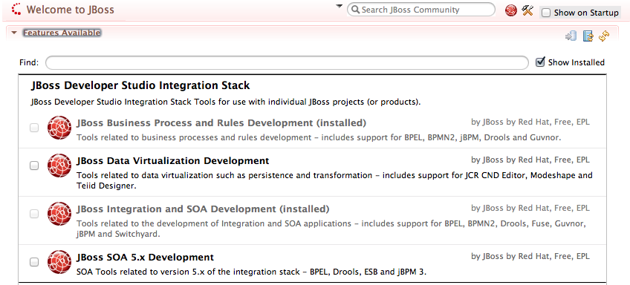
Import Projects
- Select Import... from the File menu.
- Expand the Maven folder, and then select Existing Maven Projects.
- Select the Browse button to Select root directory, you should be in the brms-fuse-integration-demo folder (if not, then navigate there) and then select OK.
- Make sure the project (brms-fuse-integration-demo) is selected and then select Finish.
- The projects are now imported.

Running the Demo

Web Designer
The business central is available on http://localhost:8080/business-central once the JBoss BPM server has been fully started.
- Login with a user (erics/bpmsuite).
- View process: Project Authoring → open business process and wait for web designer to appear.

Build package for deployment
To build your package for deployment:
- Build package: Project Authoring → Tools → Project Editor, now click Build & Deploy button and the process has been deployed to the JBoss BPM Suite server.

Run camel route which calls the BPM workflow
To run the camel route, run mvn camel:run from the simpleRoute directory, watch server log output.

